E A R L Y B I R D A W A R D

F O R C H A P T E R Y E A R B O O K

This certificate is presented to

Beta Pi

Area 5
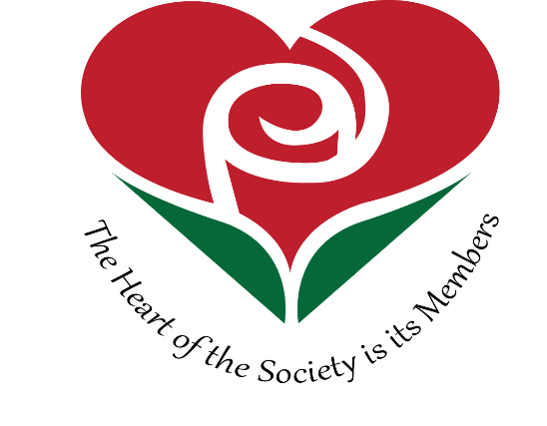 2016 - 2017

